**MEASURE ENERGY CONSUMPTION**

**Definition**

Energy monitoring and targeting is primarily a management technique that uses energy infor- mation as a basis to eliminate waste, reduce and control current level of energy use and improve the existing operating procedures. It builds on the principle **"you can't manage what you don't measure"**. It essentially combines the principles of energy use and statistics.

While, monitoring is essentially aimed at establishing the existing pattern of energy con- sumption, targeting is the identification of energy consumption level which is desirable as a management goal to work towards energy conservation.

Monitoring and Targeting is a management technique in which all plant and building utili- ties such as fuel, steam, refrigeration, compressed air, water, effluent, and electricity are man- aged as controllable resources in the same way that raw materials, finished product inventory, building occupancy, personnel and capital are managed. It involves a systematic, disciplined division of the facility into Energy Cost Centers. The utilities used in each centre are closely monitored, and the energy used is compared with production volume or any other suitable mea- sure of operation. Once this information is available on a regular basis, targets can be set, vari- ances can be spotted and interpreted, and remedial actions can betaken and implemented.

The Monitoring and Targeting programs have been so effective that they show typical reductions in annual energy costs in various industrial sectors between 5 and 20%.

**Elements of Monitoring & Targeting System**

The essential elements of M&T system are:

• **Recording** -Measuring and recording energy consumption

• **Analysing** -Correlating energy consumption to a measured output, such as production quantity

• **Comparing** -Comparing energy consumption to an appropriate standard or benchmark

• **Setting Targets** -Setting targets to reduce or control energy consumption

• **Monitoring** -Comparing energy consumption to the set target on a regular basis

• **Reporting** -Reporting the results including any variances from the targets which have been set

• **Controlling** -Implementing management measures to correct any variances, which may have occurred.

Particularly M&T system will involve the following:

• **Checking** the accuracy of energy invoices

• **Allocating** energy costs to specific departments (Energy Accounting Centres)

• **Determining** energy performance/efficiency

• **Recording** energy use, so that projects intended to improve energy efficiency can be checked

• **Highlighting** performance problems in equipment or systems

**A Rationale for Monitoring, Targeting and Reporting**

The energy used by any business varies with production processes, volumes and input. Determining the relationship of energy use to key performance indicators will allow you to determine:

• Whether your current energy is better or worse than before

• Trends in energy consumption that reflects seasonal, weekly, and other operational para- meters

• How much your future energy use is likely to vary if you change aspects of your busi-

ness

• Specific areas of wasted energy

• Comparison with other business with similar characteristics - This "benchmarking" process will provide valuable indications of effectiveness of your operations as well as

energy use

• How much your business has reacted to changes in the past

• How to develop performance targets for an energy management program

Information related to energy use may be obtained from following sources:

• Plant level information can be derived from financial accounting systems-utilities cost centre

• Plant department level information can be found in comparative energy consumption data for a group of similar facilities, service entrance meter readings etc.

• System level (for example, boiler plant) performance data can be determined from sub- metering data

• Equipment level information can be obtained from nameplate data, run-time and sched- ule information, sub-metered data on specific energy consuming equipment.

The important point to be made here is that all of these data are useful and can be processed to yield information about facility performance.

**Data and Information Analysis**

Electricity bills and other fuel bills should be collected periodically and analysed as below. A typical format for monitoring plant level information is given below in the Table 8.1.

|  |  |  |  |  |  |  |  |  |  |
| --- | --- | --- | --- | --- | --- | --- | --- | --- | --- |
| ANNUAL ENERGY COST SHEET | | | | | | | | | |
|  | **Thermal Energy Bill** | | | | **Electricity Bill** | | | | **Total**  **Energy Bill** |
| **Month** | **Fuel 1** | **Fuel 2** | **Fuel 3** | **Total**  **Rs. Lakh** | **Day**  **kWh** | **Night kWh** | **Maximum Demand** | **Total**  **Rs. Lakh** | **Rs.Lakh** |
| 1 |  |  |  |  |  |  |  |  |  |
| 2 |  |  |  |  |  |  |  |  |  |
| 3 |  |  |  |  |  |  |  |  |  |
| 4 |  |  |  |  |  |  |  |  |  |
| 5 |  |  |  |  |  |  |  |  |  |
| 6 |  |  |  |  |  |  |  |  |  |
| 7 |  |  |  |  |  |  |  |  |  |
| 8 |  |  |  |  |  |  |  |  |  |
| 9 |  |  |  |  |  |  |  |  |  |
| 10 |  |  |  |  |  |  |  |  |  |
| 11 |  |  |  |  |  |  |  |  |  |
| 12 |  |  |  |  |  |  |  |  |  |
| Sub-Total |  |  |  |  |  |  |  |  |  |
| % |  |  |  |  |  |  |  |  |  |

After obtaining the respective annual energy cost, a pie chart (see Figure 8.1) can be drawn as shown below:



**% Share of Fuels Based on Energy Bill**

**Pie Chart on Energy Consumption**

All the fuels purchased by the plant should be converted into common units such as kCal. The following Table 8.2 below is for that purpose.

|  |  |  |
| --- | --- | --- |
| FUEL CONVERSION DATA | | |
| **Energy source** | **Supply unit** | **Conversion Factor to Kcal** |
| Electricity | kWh | 860 |
| HSD | Kg | 10,500 |
| Furnace Oil | Kg | 10,200 |
| LPG | Kg | 12,000 |

After conversion to a common unit, a pie chart can be drawn showing the percentage dis- tribution of energy consumption as shown in Figure 8.2.

|  |
| --- |
|  |
|  |

**%Share of Fuels Based on Consumption in kCals**

**Relating Energy Consumption and Production.**

**Graphing the Data**

A critical feature of M&T is to understand what drives energy consumption. Is it production, hours of operation or weather? Knowing this, we can then start to analyse the data to see how good our energy management is.

After collection of energy consumption, energy cost and production data, the next stage of the monitoring process is to study and analyse the data to understand what is happening in the plant. It is strongly recommended that the data be presented graphically. A better appreciation of variations is almost always obtained from a visual presentation, rather than from a table of numbers. Graphs generally provide an effective means of developing the energy-production relationships, which explain what is going on in the plant.

**Use of Bar Chart**

The energy data is then entered into a spreadsheet. It is hard to envisage what is happening from plain data, so we need to present the data using bar chart. The starting point is to collect and collate 24/12 months of energy bills. The most common bar chart application used in energy

management is one showing the energy per month for this year and last year (see Figure 8.3) - however, it does not tell us the full story about what is happening. We will also need produc- tion data for the same 24/12-month period.

Having more than twelve months of production and energy data, we can plot a moving

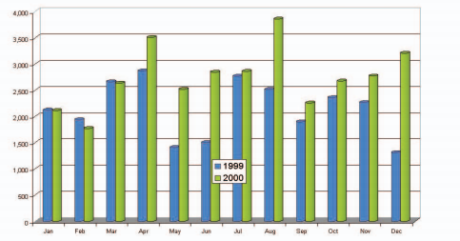

**Energy Consumption :Current Year(2000) Vs. Previous year(1999)**

annual total. For this chart, each point represents the sum of the previous twelve months of data. In this way, each point covers a full range of the seasons, holidays, etc. The Figure 8.4 shows a moving annual total for energy and production data.

This technique also smoothens out errors in the timing of meter readings. If we just plot energy we are only seeing part of the story - so we plot both energy and production on the same chart - most likely using two y-axes. Looking at these charts, both energy and productions seem to be "tracking" each other - this suggests there is no major cause for concern. But we will need to watch for a deviation of the energy line to pick up early warning of waste or to confirm whether energy efficiency measures are making an impact.

For any company, we also know that energy should directly relate to production. Knowing this, we can calculate Specific Energy Consumption (SEC), which is energy consumption per unit of production. So we now plot a chart of SEC.

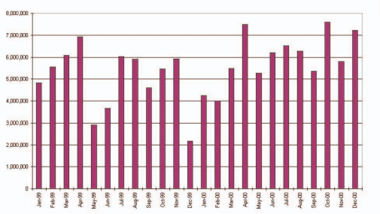

**Monthly Specific Energy Consumption**

At this point it is worth noting that the quality of your M&T system will only be as good as the quality of your data - both energy and production. The chart shows some variation - an all time low in December 99 followed by a rising trend in SEC.

We also know that the level of production may have an effect on the specific consumption. If we add the production data to the SEC chart, it helps to explain some of the features. For example, the very low SEC occurred when there was a record level of production. This indi- cates that there might be fixed energy consumption - i.e. consumption that occurs regardless of production levels.

The next step is to gain more understanding of the relationship of energy and production, and to provide us with some basis for performance measurement. To do this we plot energy against production - In Microsoft Excel Worksheet, this is an XY chart option. We then add a trend line to the data set on the chart. (In practice what we have done is carried out a single variable regression analysis!). The Figure 8.7 shown is based on the data for 1999.

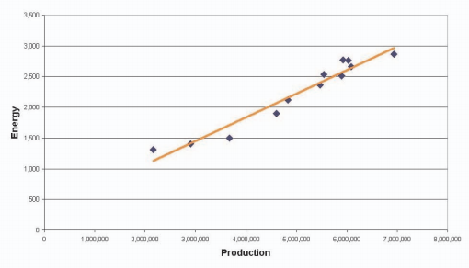

**Energy vs Production**

We can use it to derive a "standard" for the up-coming year's consumption. This chart shows a low degree of scatter indicative of a good fit. We need not worry if our data fit is not good. If data fit is poor, but we know there should be a relationship, it indicates a poor level of control and hence a potential for energy savings.

In producing the production/energy relationship chart we have also obtained a relationship relating production and energy consumption.

**Energy consumed for the period = C + M x Production for same period**

Where M is the energy consumption directly related to production (variable) and C is the *"fixed"* energy consumption (i.e. energy consumed for lighting, heating/cooling and general ancillary services that are not affected by production levels). Using this, we can calculate the expected or "standard" energy consumption for any level of production within the range of the data set.

We now have the basis for implementing a factory level M&T system. We can predict stan- dard consumption, and also set targets - for example, standard less 5%. A more sophisticated approach might be applying different reductions to the fixed and variable energy consumption. Although, the above approach is at factory level, the same can be extended to individual processes as well with sub metering.

At a simplistic level we could use the chart above and plot each new month's point to see where it lies. Above the line is the regime of poor energy efficiency, and below the line is the regime of an improved one.

**CUSUM**

Cumulative Sum (CUSUM) represents the difference between the baseline (expected or stan- dard consumption) and the actual consumption points over the baseline period of time.

This useful technique not only provides a trend line, it also calculates savings/losses to date and shows when the performance changes.

A typical CUSUM graph follows a trend and shows the random fluctuation of energy con- sumption and should oscillate around zero (standard or expected consumption). This trend will continue until something happens to alter the pattern of consumption such as the effect of an energy saving measure or, conversely, a worsening in energy efficiency (poor control, house- keeping or maintenance).

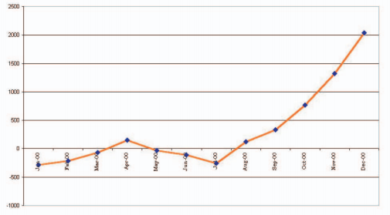

**CUSUM Chart**

CUSUM chart (see Figure 8.8) for a generic company is shown. The CUSUM chart shows what is really happening to the energy performance. The formula derived from the 1999 data was used to calculate the expected or standard energy consumption.

From the chart, it can be seen that starting from year 2000, performance is better than stan- dard. Performance then declined (line going up) until April, and then it started to improve until July. However, from July onwards, there is a marked, ongoing decline in performance - line going up.

When looking at CUSUM chart, the changes in direction of the line indicate events that have relevance to the energy consumption pattern. Clearly, site knowledge is needed to inter- pret better what they are. For this sample company since we know that there were no planned changes in the energy system, the change in performance can be attributed to poor control, housekeeping or maintenance.

**Case Study**

**The CUSUM Technique**

Energy consumption and production data were collected for a plant over a period of 18 months. During month 9, a heat recovery system was installed. Using the plant monthly data, estimate the savings made with the heat recovery system. The plant data is given in Table 8.3:

|  |  |  |
| --- | --- | --- |
| MONTH WISE PRODUCTION WITH ENERGY CONSUMPTION | | |
| **Month** | **Eact - Monthly Energy Use ( toe * / month)** | **P - Monthly Production ( tonnes / month)** |
| 1 | 340 | 380 |
| 2 | 340 | 440 |
| 3 | 380 | 460 |
| 4 | 380 | 520 |
| 5 | 300 | 320 |
| 6 | 400 | 520 |
| 7 | 280 | 240 |
| 8 | 424 | 620 |
| 9 | 420 | 600 |
| 10 | 400 | 560 |
| 11 | 360 | 440 |
| 12 | 320 | 360 |
| 13 | 340 | 420 |
| 14 | 372 | 480 |
| 15 | 380 | 540 |
| 16 | 280 | 280 |
| 17 | 280 | 260 |
| 18 | 380 | 500 |

**\*toe = tonnes of oil equivalent.**

**Steps for CUSUM analysis**

1. Plot the Energy - Production graph for the first 9 months

2. Draw the best fit straight line

3. Derive the equation of the line

The above steps are completed in Figure 8.9, the equation derived is E = 0.4 P + 180

4. Calculate the expected energy consumption based on the equation

5. Calculate the difference between actual and calculated energy use

6. Compute CUSUM

|  |  |  |  |  |  |
| --- | --- | --- | --- | --- | --- |
| CUSUM | | | | | |
| **Month** | **Eact** | **P** | **Ecalc**  **(0.4 P + 180)** | **Eact** – **Ecalc** | **CUSUM**  **(Cumulative Sum)** |
| 1 | 340 | 380 | 332 | +8 | +8 |
| 2 | 340 | 440 | 356 | -16 | -8 |
| 3 | 380 | 460 | 364 | +16 | +8 |
| 4 | 380 | 520 | 388 | -8 | 0 |
| 5 | 300 | 320 | 308 | -8 | -8 |
| 6 | 400 | 520 | 388 | +2 | -6 |
| 7 | 280 | 240 | 276 | +4 | -2 |
| 8 | 424 | 620 | 428 | -4 | -6 |
| 9 | 420 | 600 | 420 | 0 | -6 |
| 10 | 400 | 560 | 404 | 4 | -10 |
| 11 | 360 | 440 | 356 | +4 | -6 |
| 12 | 320 | 360 | 324 | -4 | -10 |
| 13 | 340 | 420 | 348 | -8 | -18 |
| 14 | 372 | 480 | 372 | 0 | -18 |
| 15 | 380 | 540 | 396 | -16 | -34 |
| 16 | 280 | 280 | 292 | -12 | -46 |
| 17 | 280 | 260 | 284 | -4 | -50 |
| 18 | 380 | 500 | 380 | 0 | -50 |

Eact- Actual Energy consumption Ecalc - Calculated energy consumption

7. Plot the CUSUM graph

8. Estimate the savings accumulated from use of the heat recovery system.

From it can be seen that the CUSUM graph oscillates around the zero line for several months and then drops sharply after month 11. This suggests that the heat recovery sys- tem took almost two months to commission and reach proper operating conditions, after which steady savings have been achieved. Based on the graph 8.10 (see Table 8.4), savings of 44 toe (50-6) have been accumulated in the last 7 months. This represents savings of almost 2% of energy consumption.

 . 100 = 1.8%

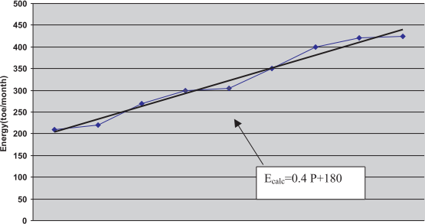



**Energy Production Graph**

#Eact for the last 7 months (from month 12 to month 18 in Table 8.4)





|  |  |
| --- | --- |
|  | |
|  |  |
|  | |
|  | |
|  | |
|  | |
|  | |
|  | |



**Example CUSUM Graph**

CUSUM chart for last 18 months is shown in Figure 8.10.

The CUSUM technique is a simple but remarkably powerful statistical method, which high- lights small differences in energy efficiency performances. Regular use of the procedure allows the Energy Manager to follow plant performance and spot any trends early.

|  |  |
| --- | --- |
| **QUESTIONS** | |
| 1. | What is the difference between monitoring and targeting? |
| 2. | Explain briefly the essential elements of a monitoring and targeting system. |
| 3. | What are the benefits of a monitoring and targeting system? |
| 4. | What do you understand by the term "benchmarking" and list few benefits? |
| 5. | Explain the difference between internal and external benchmarking. |
| 6. | Explain how a CUSUM chart is drawn with an example. |
| 7. | Narrate the type of energy monitoring and targeting systems in your industry. |

**REFERENCES**

1. Energy conservation – The Indian experience, Department of Power & NPC Publication

2. Energy Audit Reports of National Productivity Council

3. Cleaner Production – Energy Efficiency Manual prepared for GERIAP, UNEP, BANGKOK by National Produ